

A Project

Report On

**Hotel Management System**

**By**

**BhavithavyaKolluri**

**BTECH**

**Batch:** 2021 – 5883

Under the Guidance of,

**Mamta Boga**

**Technical Trainer**

**EduBridge**

(School of coding)

**Introduction:**

This hotel management system is developed for hotels those are using a manual system to handle hotel processes. This system will automate the major operations of the hotel. There are two main users in hotel management system administrator and guests. Administrator can see about the employees and the hotel bookings.Administrator can also edit and delete the details of the employee and guest without any restrictions. The guests can view the hotel web site and can sign up and book the hotel room they want by using different type of payment methods.

**List of Modules**

* **Admin**
* **Signup**
* **Room Booking**
* **Employee**
* **Check Out and Payments**

I have developed this Application in **Java, Springboot, Hibernate and MySQL.** It’s a web-based project so I have used **HTML, CSS, JavaScript and Bootstrap also**.

The main feature of the project is to make hotel booking easier. You can access this website from anywhere and everywhere.

**Admin :**

Here,Admin can login and access booking detail and employee related information.

In booking list admin can see different users booking the rooms and can perform CRUD operations like edit ,delete and update the list.

In employee list admin can see all details of employees who are working in HBHR'S hotel and perform CRUD operations like edit,delete and update the list.

**Payment :**

To get the guest to book the hotel we use the payment option where the guest can use different payment methods like using cash to pay or cards by giving the costumer card details. After choosing the cash method or by doing using the card payment method the hotel gets booked for the guest and then he gets a pop up message that the hotel room is booked.

**Aboutus :**

In about us page the users can read about the hotel details, services provided and the view of the hotel. It also redirects the user to the hotel booking page to sign up.

**Software Requirements:**

**Front end:** Java/J2EE technologies (SpringBoot Framework), HTML, CSS, JavaScript, Bootstrap, Hibernate.

**Back end**: MySQL workbench 8.0.23CE.

**Middleware/Server:** Apache Tomcat v7.0. IDE: Eclipse IDE for Java EE Developers

**Browser:** Best result on Google Chrome

**Operating System:** Window 10.

**Screenshots:-**

**Home Page:**

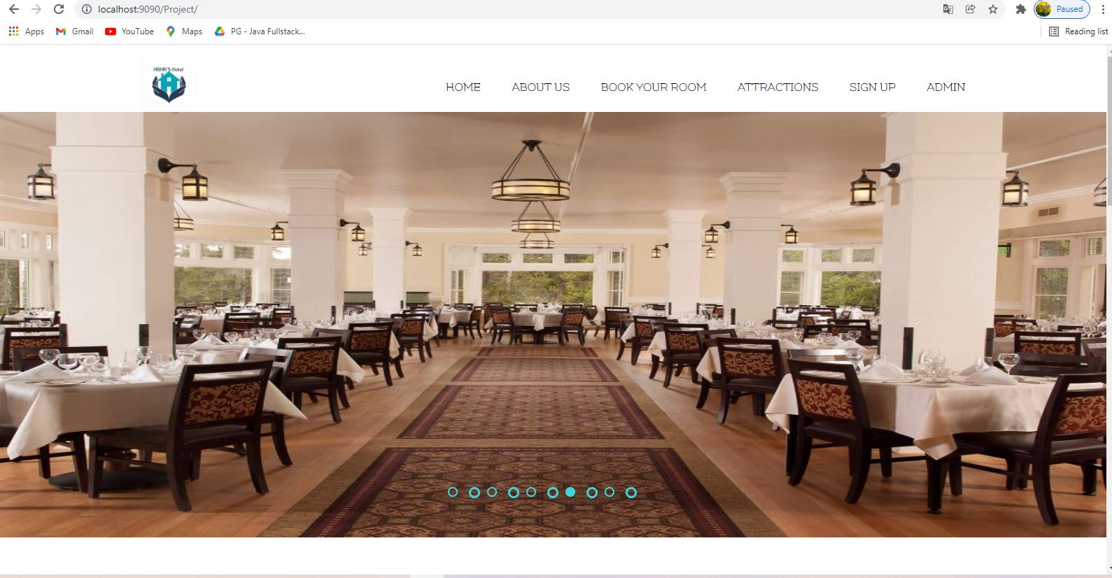

**Signup Page:** Here, user gives his details to book the room according to the type of room he wants.

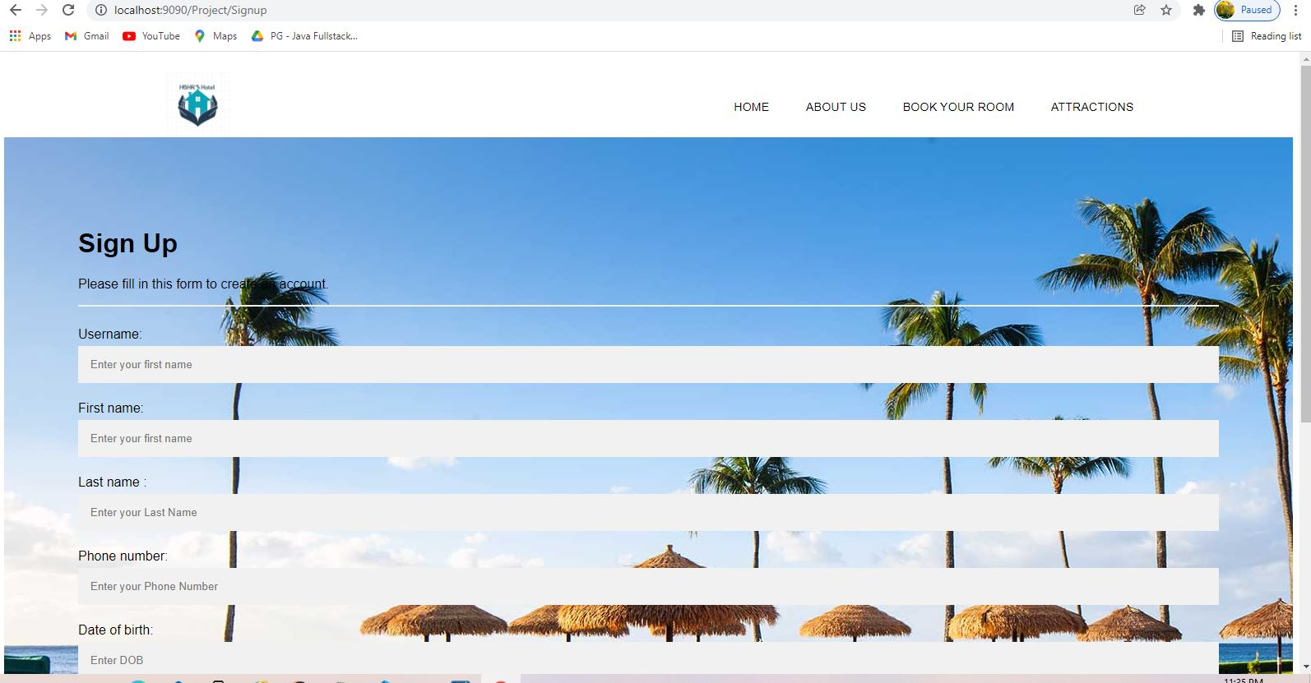

**Signup With Data:**

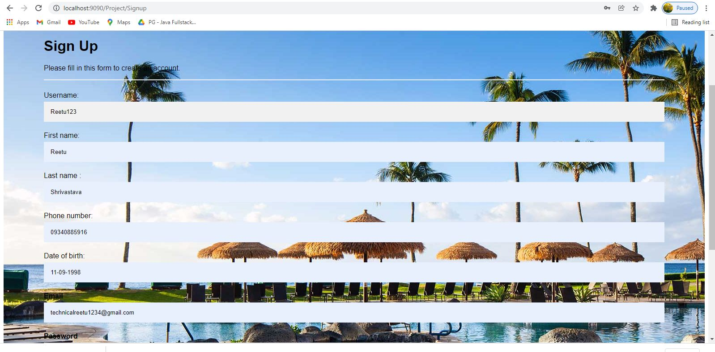

**Successful Signup Done:**

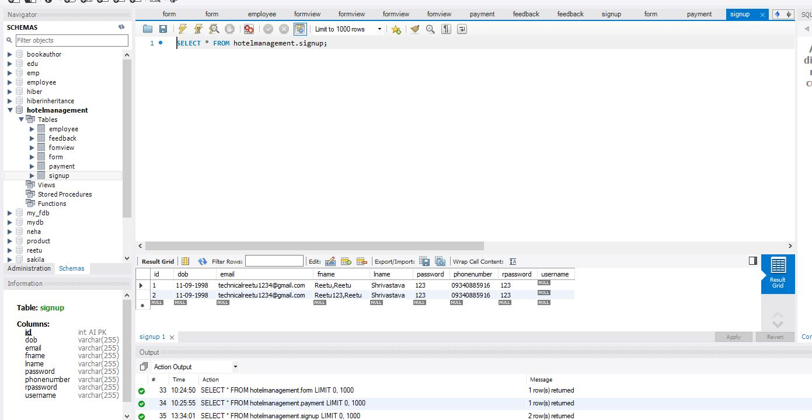

**Admin Page:**

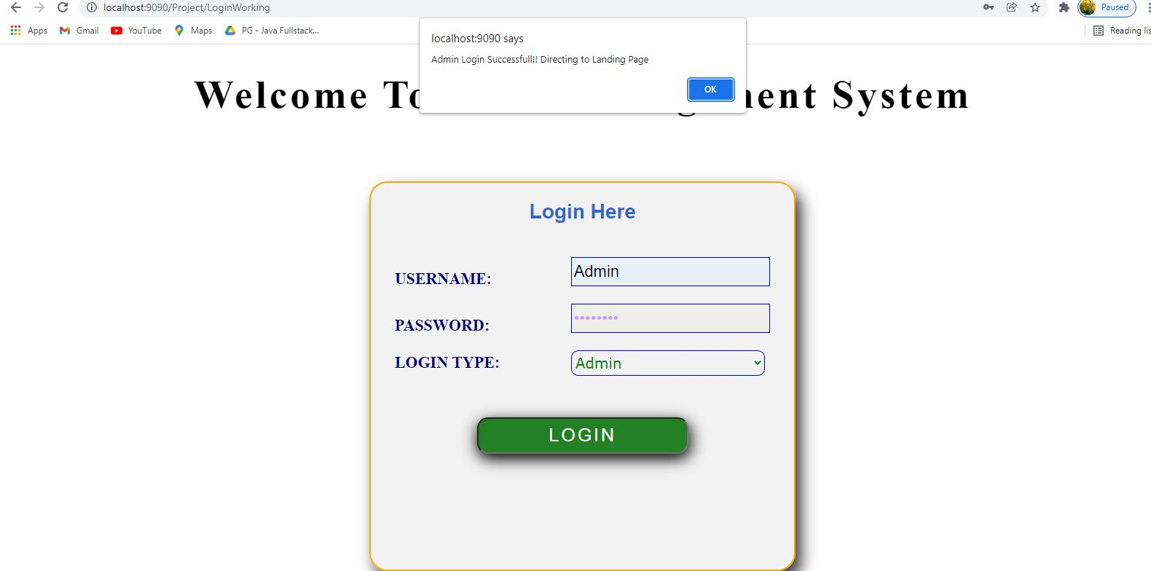

**Admin Dashboard Page:**

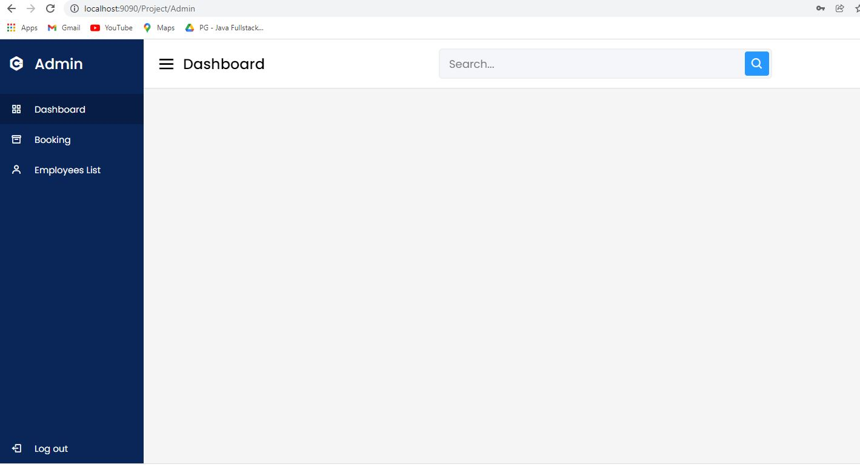

**User Booking Data by Admin :**

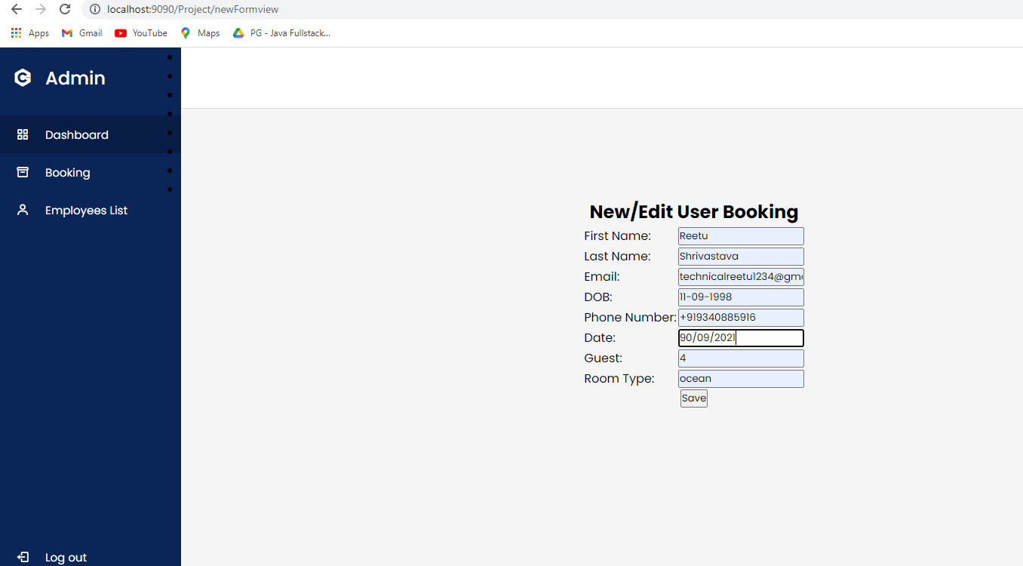

**Booking List :**

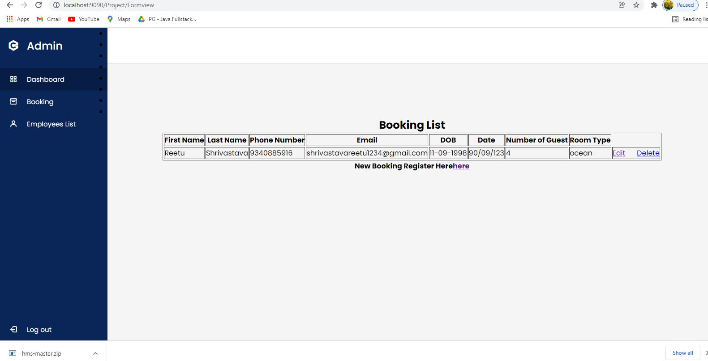

**Successful Booking List Done:**

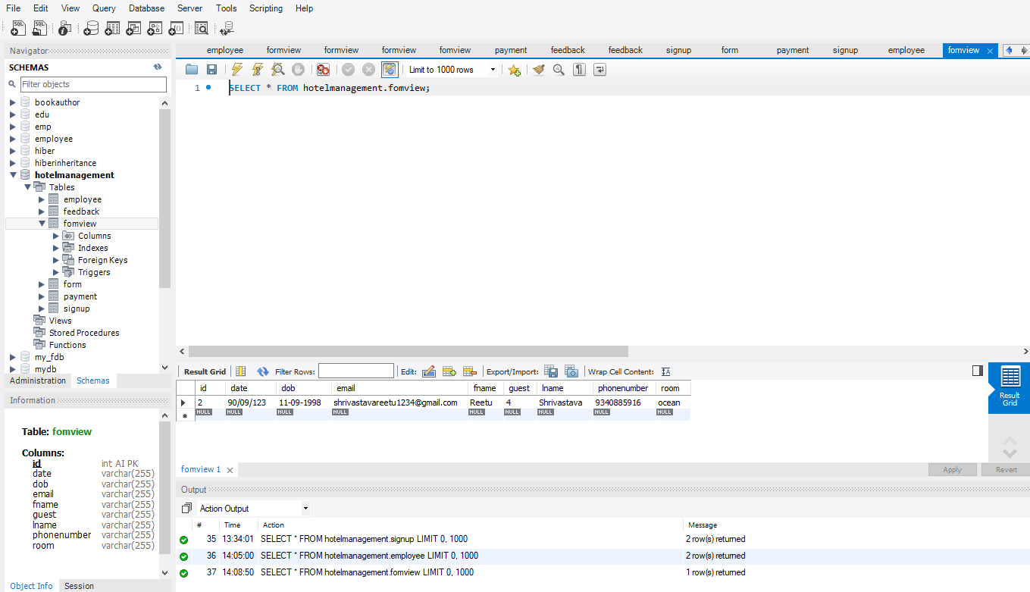

**Employee Data by Admin:**

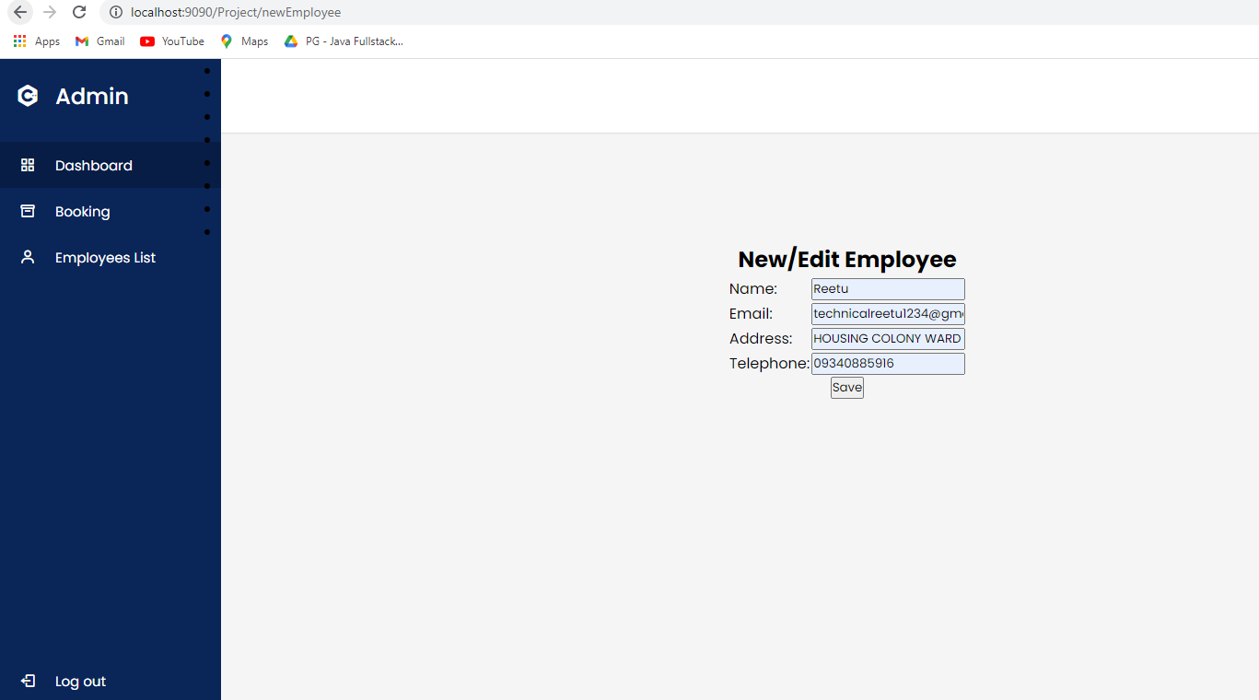

**Employee List:**

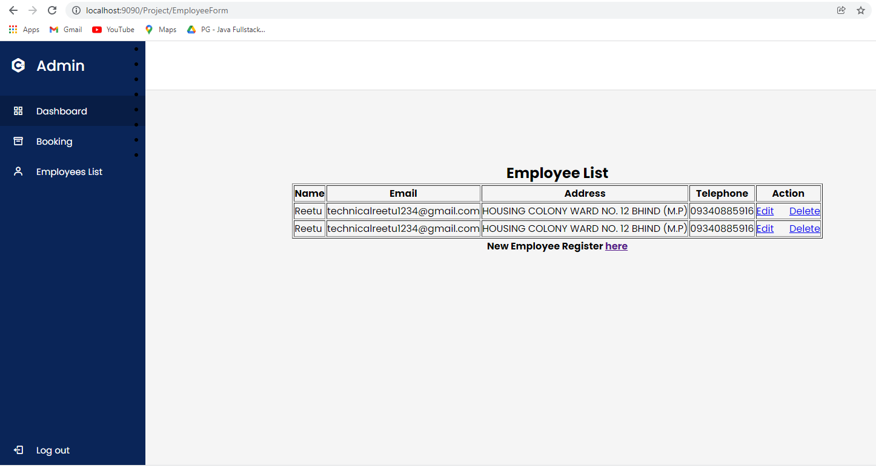

**Successful Booking List Done:**

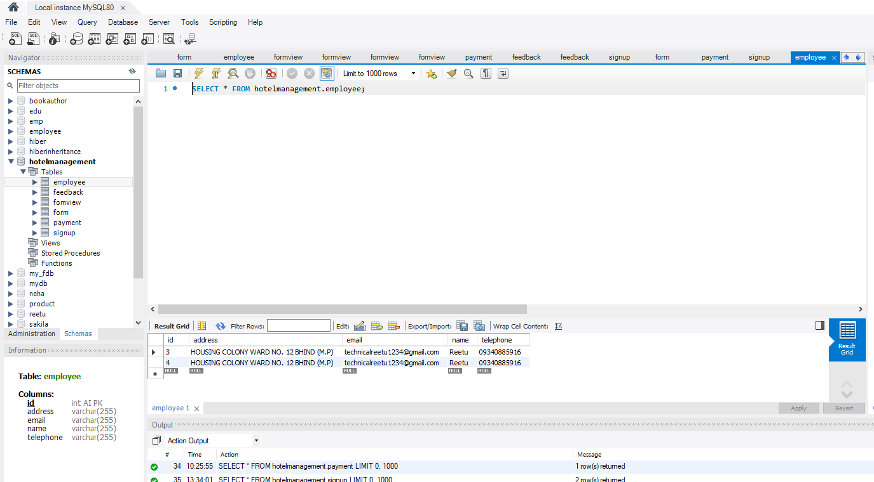

**About Us:**

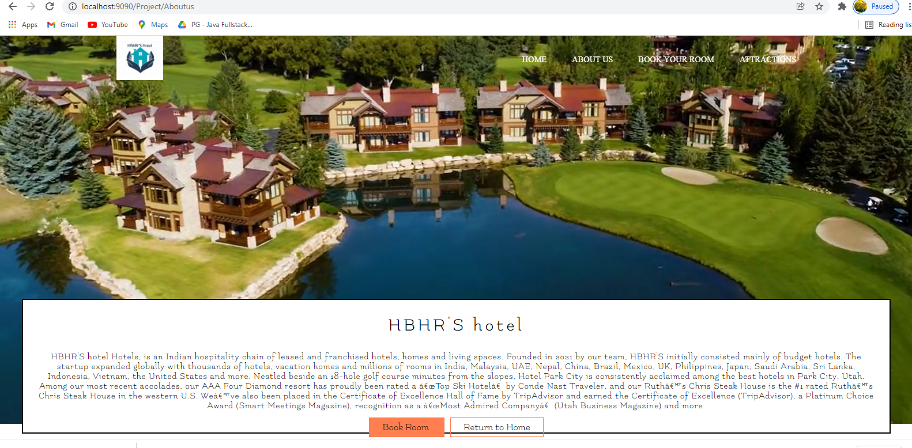

**Attraction :**In attractions page the user can see the different types of rooms as images for getting better idea of how the rooms appearance.

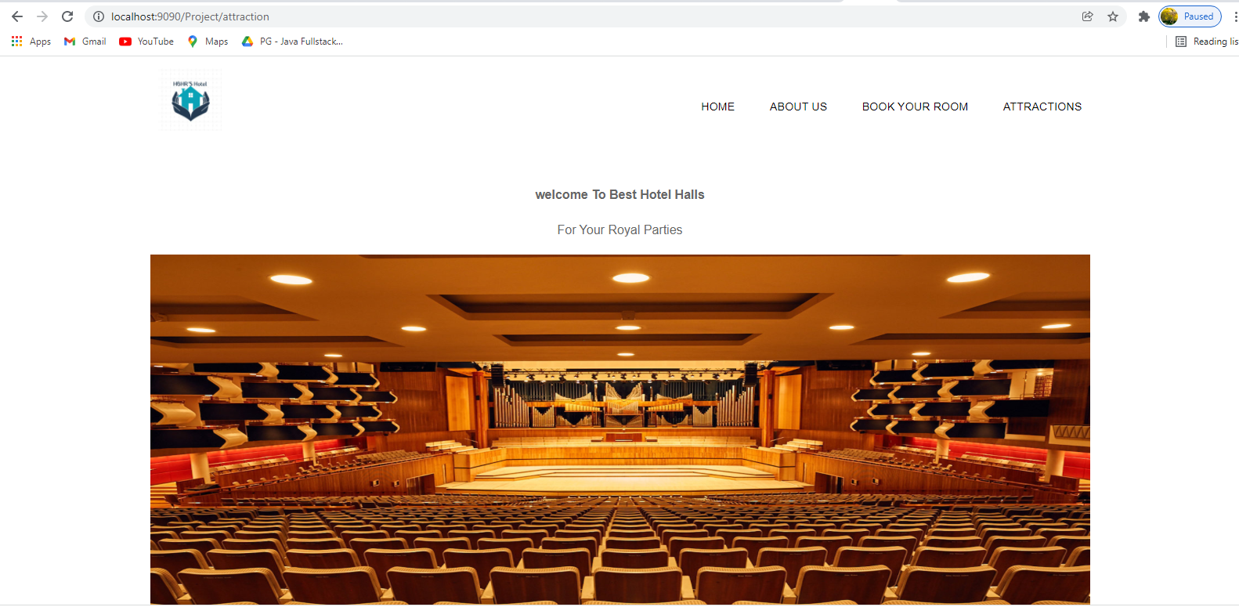

**Booking Form Data:** After signup user can book different types of rooms which are available in HBHR'S Hotel.

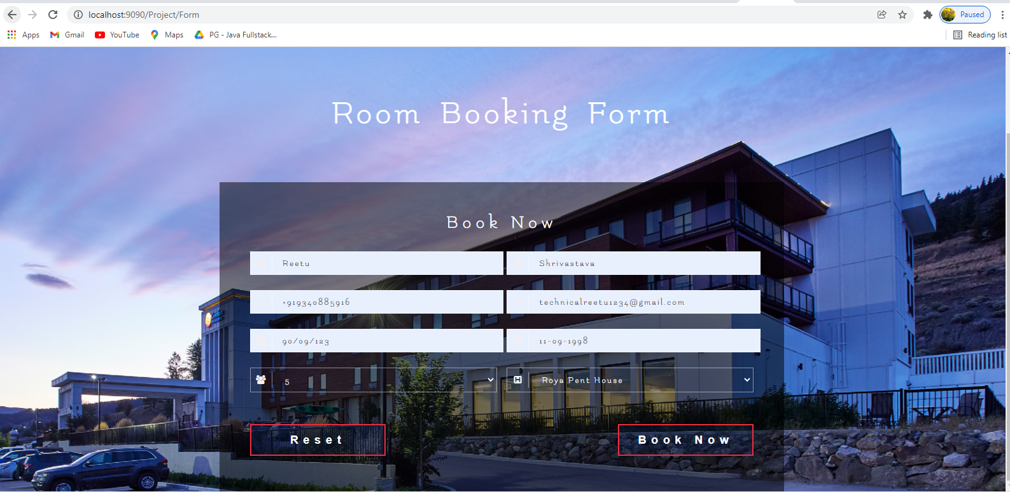

**Successful Booking :**

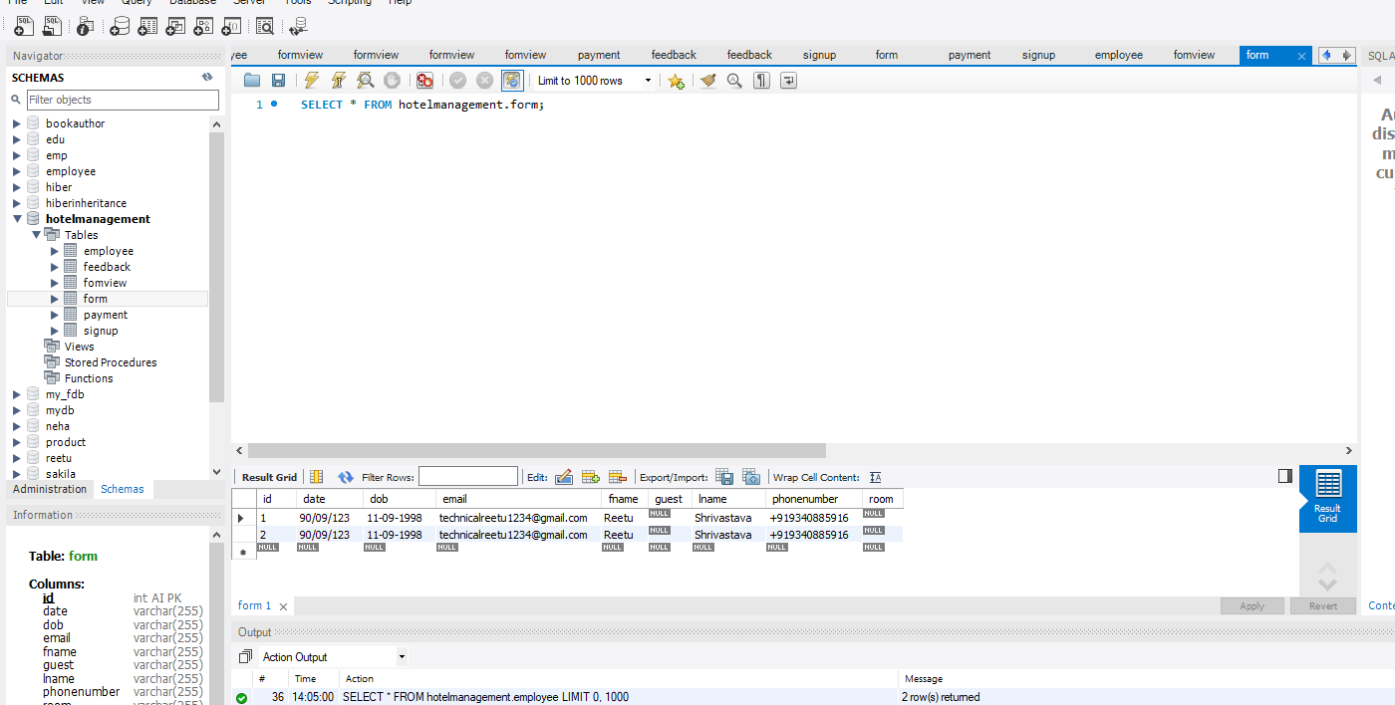

**Payment Form:**

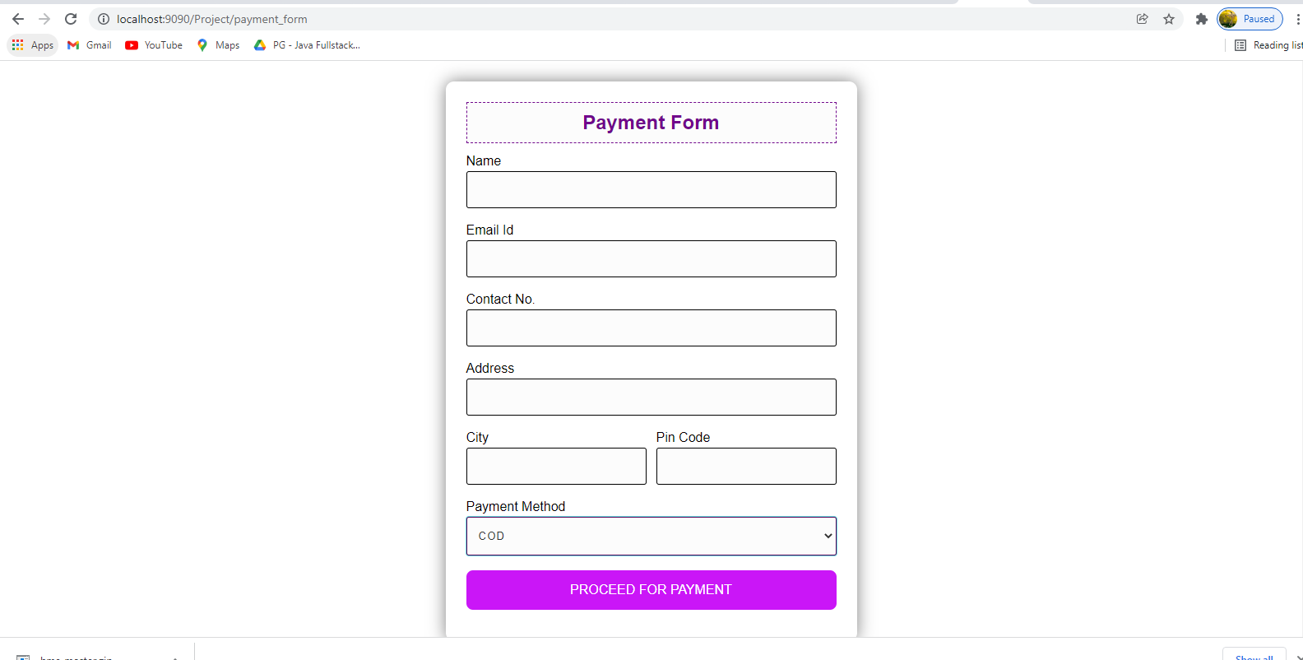

**Payment Form with Data:**

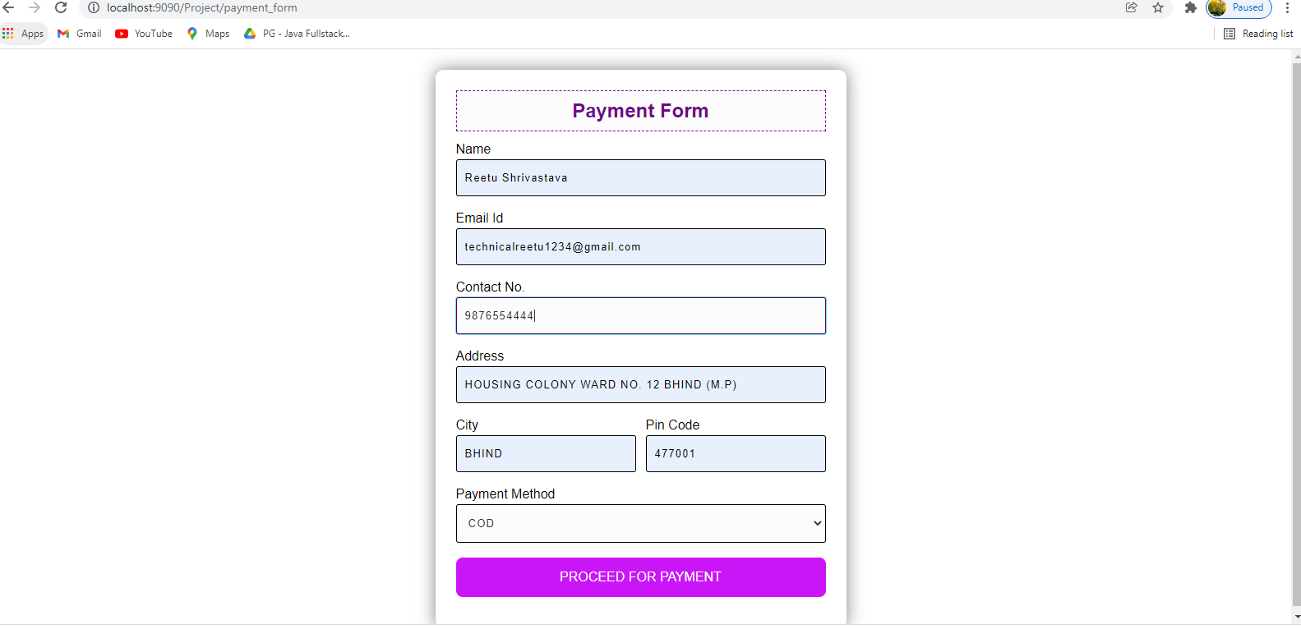

**Successful Payment Done:**

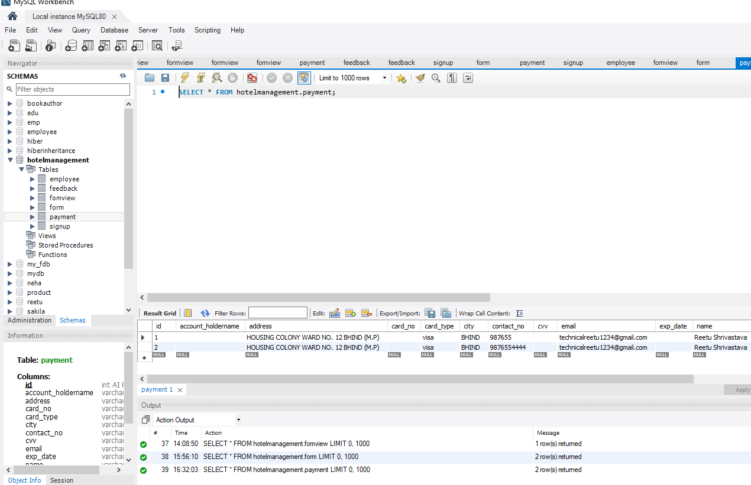

**Thank you**